Title: Developing a Turn-Based Combat Game as a Tool for Strategic Skill Acquisition
Vision
This project is for primarily young learners, whose problem is learning key skills traditional education struggles to teach in a fun and practical format. Plans & perils is a game that teaches long-term strategies and short-term tactics for a group with different strengths and weaknesses. It also teaches the importance of planning before committing to actions. It will teach them how to utilise these to perform the best against challenging and varied situations. The turn-based structure encourages this with thoughtful decision making and allows players to experiment with different approaches. The level-up and ability system allows players to pick and choose a strategy they think is best. This will help players to try a variety of strategies to think more broadly about options that may not be their favourite but are better in certain situations. The art-style will be pixel art based as this will have an aesthetic more suited to a younger audience but can also be enjoyed by older players. The enemies will have different levels of strategy to challenge the player with their strategic thinking to find flaws in strategies and utilise them effectively. It will also be designed in a way that all the controls are very basic so that it is easier for players to learn how to play with the possibility in the future to port to different platforms (e.g. mobile) to allow a wider range of people to play.

Risk plan
Risks - clear licence checking (audio), No personal data used, consider age-appropriate content, fair randomness, accessible settings, support / warnings (warning when played for x time e.g. “You’ve been playing for an hour how about having a 15-minute break.”), easy exit / breaks in gameplay, QA testing, fair work practices

There are many risks associated with this project, in this section I will discuss the most threatening to the project as a whole. The first risk is not having clear licence checking for all assets I do not make myself to make certain I don’t infringe on any copyright. To do this I will check the licence thoroughly before downloading and implementing. An additional risk is not having age-appropriate content for my target audience; to reduce this risk I will follow the PEGI 3 guidelines to ensure that anyone can use my product. Additionally, a risk is my product not being accessible for all audiences. To reduce this risk, I am using a reduced control set where only the mouse is used and possible touchscreen support, along with some accessibility settings to aid this further. Finally, a risk for my product is causing negative social effects on my younger audience as they are more impressionable and can develop bad habits for life. To reduce this risk, I will include features such as having warnings after 30 minutes of playtime to take a break and having rewards achievement-based rather than time-based. I will also include easy exit from the game and regular breaks within gameplay.
LSEP
L - Copyright / IP issues, Use of third-party content, Age ratings / content rating laws / compliance (PEGI)
S - Social isolation or negative impact on mental health, Impact on younger players (developmental concerns), Effects of competition / stress
E - Addiction / excessive engagement; encouraging overuse, Emotional manipulation (reward schedules, feedback loops), Inaccurate or harmful representations (gender, race, culture)
P - Accountability (bugged / unfair design), Ethical working conditions, Responsibility of game creators to their audience (proper support and if selling it having an accurate product)

There are many considerations when making this project. Some of the legal considerations are copyright infringement. To eliminate this, I will be producing the majority of assets myself, except for audio, which I will use Creative Commons licensed audio clips and making sure I follow the licence correctly. Any future updates or community contributions would continue to respect licensing. I will also attribute sources where required in the game’s credits. Another issue is being compliant with content rating laws/ regulations. As my game is targeted towards a younger audience, I will have to make sure that the content is appropriate for them. To do this, I will follow the PEGI 3 guidelines because they include “very mild form of violence” and “no bad language”.
Some of the social considerations are that I will also have to make sure that my game has plenty of breaks in the gameplay to avoid any negative effects of playing games for a long time. To do this, I will also put up a warning after 30 minutes of playtime to remind players to take a break. I will also have to ensure the game is fair, as making it too stressful to play may have some ill effects on younger players’ mental state. I will make the difficulty scales over time, with the option of choosing the difficulty played at, as more confident players can challenge themselves, so that the game remains positive and educational.
To ensure ethical responsibilities are being met, I will have no emotional manipulation with reward schedules or feedback loops. To ensure this does not happen, I will follow game design principles such as being transparent with the inner workings of the game. I will also ensure I don’t design the game to encourage overuse, with any rewards for play time; the rewards will be achievement-based rather than time-based. Also, I will have to ensure that I don’t have any inaccurate or harmful representations for my characters, including race, gender and culture. I will follow inclusive design principles to make sure this doesn’t happen. I will also make sure the game is accessible for younger audiences by using clear fonts and simpler language. I do not need to consider personal data collection and storage, as I will not be collecting any.
To make certain this project is undertaken professionally, I will make sure I am working in ethical conditions, such as safe working practices, realistic deadlines, and a balance between work and wellbeing to ensure I am maintaining sustainable development practices. To make sure I am working professionally, I will follow the BCS code of conduct. I will also need to consider the responsibilities of game creators to their audience. This includes proper support for bugs or unfair design decisions, and providing an accurate and worthwhile product. I will test the game extensively, with user-testing and bug tracking, before releasing it so that I can confirm this.
GANTT Chart
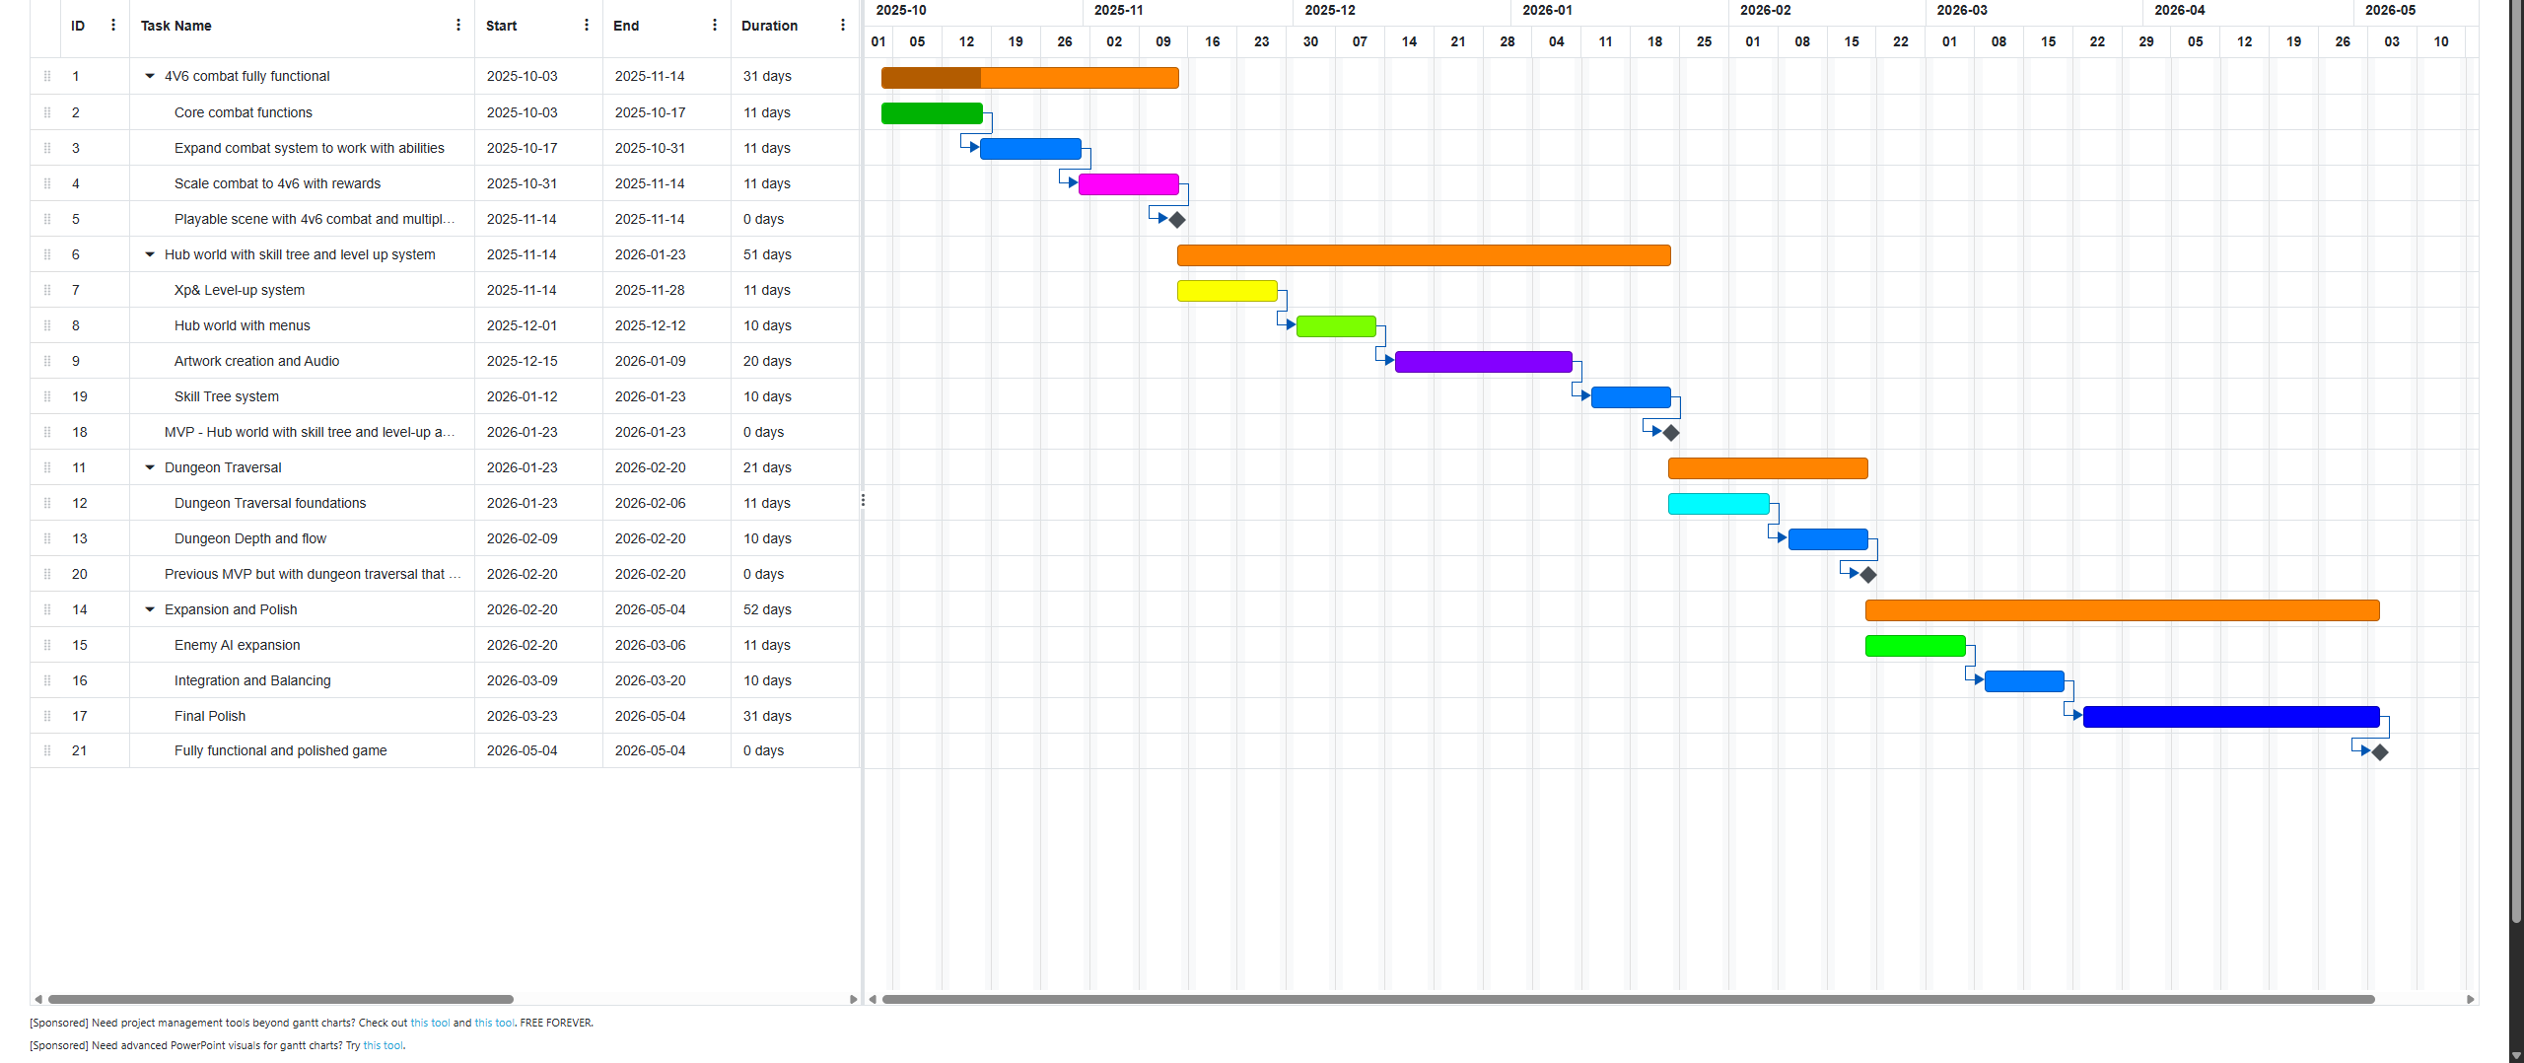

Wireframes
Combat UI -

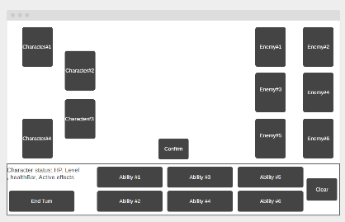

Hub world UI 1 – buttons on left to upgrade and make a ‘build’ for each character the middle will be a ‘notice board’ with ‘jobs’ of different dungeons to take.
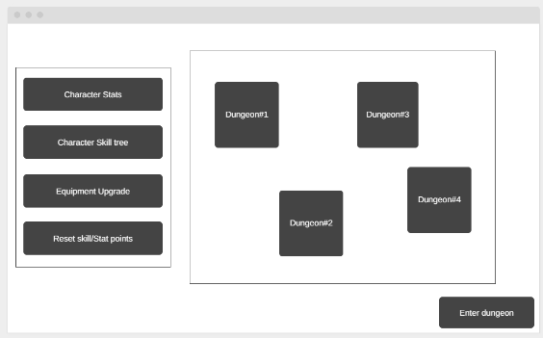
When a button on left is clicked this will show up to select a character for the function picked
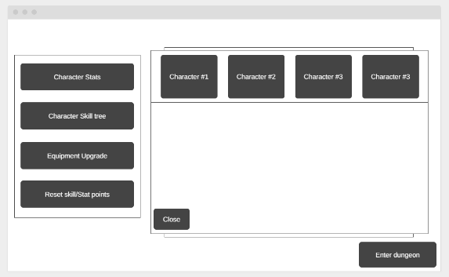
Hub world UI 2 – a scene with hidden buttons that bring up the same upgrade menus (more visual) for example having a blacksmith for upgrading the equipment. (More art intensive and need a way for players to know what they can click) using MVVM I can always implement the idea later on as buttons will have the same functionality. Would only need a new button to show notice board up close.

Literature review notes
- https://www.theseus.fi/bitstream/handle/10024/500525/XiaoXuejian.pdf;jsessionid=26E899A6AF72C775677DC04A855AF749?sequence=2 -- MVVM framework for Unity3D
- https://arxiv.org/abs/2508.01623 - Pokémon style combat AI
- https://arxiv.org/abs/2205.09693 - changes team members reduces performance initially then recovers. (Player can change characters build which will change how they manage their team and change strategy)
- https://arxiv.org/abs/2006.10808 - ethical considerations for games
- https://arxiv.org/abs/2407.04892 - Diversity, representation and Accessibility concerns in game development
- https://link.springer.com/article/10.1007/s44192-025-00220-7 - Social context in the development of problematic gaming habits (games target audience is young learners, bad habits can develop easier)
- https://bmcpsychiatry.biomedcentral.com/articles/10.1186/s12888-023-05265-y - Association of internet gaming disorder with impulsivity
- https://link.springer.com/article/10.1007/s10676-017-9416-6 - Game mechanics and technological mediation (reward systems, mechanics that influence behaviour, incentive structures, how mechanics can manipulate user behaviour)

To do:
- Find evidence for why I picked solution for aim: (why pokemon style combat, why turn based not real time, strategy games improving skills, games improving real world skills) especially for younger learners.

